List Files - Code Source

1-List Folder Files - Ai Question - id 1
# Source: Person Source: Provided by: [Data Path: Persons Table -> ID Column: 1, Name_En Column: Motasem Essam] Written by: [Data Path: Persons Table -> ID Column: 1, Name_En Column: Motasem Essam] on [11/17/2025]
give me python code to get names of each file with extension in specific folder give me way to select folder by window and list all files with their extensions inside that folder.

2-List Folder Files - Ai Answer - id 1
# Source: AI Source: Provided by: [Data Path: Persons Table -> ID Column: 1, Name_En Column: Motasem Essam] -> From: [ChatGPT] on [11/17/2025]
Here is a simple and clean way to pick a folder using a Windows dialog and then list all files with their extensions inside that folder.
✅ Option 1 — tkinter (built-in, easiest)
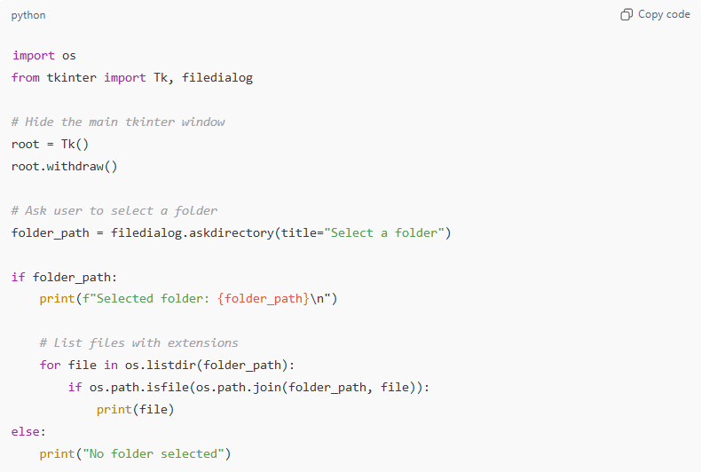
import os
from tkinter import Tk, filedialog

# Hide the main tkinter window
root = Tk()
root.withdraw()

# Ask user to select a folder
folder_path = filedialog.askdirectory(title="Select a folder")

if folder_path:
print(f"Selected folder: {folder_path}\n")

# List files with extensions
for file in os.listdir(folder_path):
if os.path.isfile(os.path.join(folder_path, file)):
print(file)
else:
print("No folder selected")

✅ Option 2 — If you want only files with a specific extension
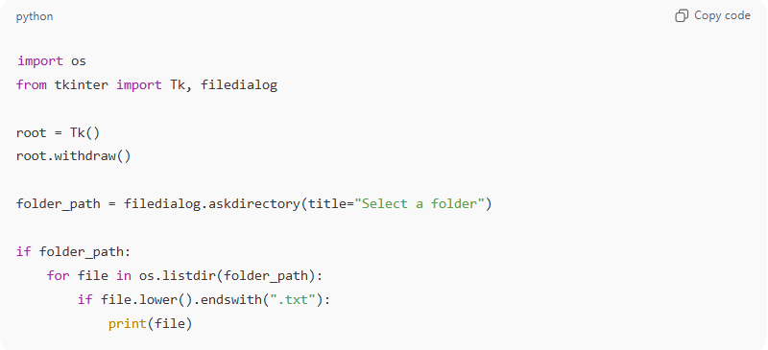
Example: only .txt files.
import os
from tkinter import Tk, filedialog

root = Tk()
root.withdraw()

folder_path = filedialog.askdirectory(title="Select a folder")

if folder_path:
for file in os.listdir(folder_path):
if file.lower().endswith(".txt"):
print(file)

💡 How it works
- filedialog.askdirectory() opens a Windows folder-selection dialog
- os.listdir() gives all items inside the folder
- os.path.isfile() ensures we only print files
- prints full filenames with extensions

